Get-FolderSize Installation, usage and troubleshooting guide

# Get-FolderSize Function displays size of all folders in a specified path. This tool is useful if you want to determine large folders in a particular path.

# Requirements

* At least PoWerShell 2.0 on the PC you are running the function.
* Access to the folders in the path specified.

# Functionalities / Features

The function has the following features:

* Supports folder paths in UNC or local format.
* Reports folders greater than or equal to a specified size in GB
* Returns Folder name, Path and Size in GB.
* Includes full help and examples

# Installation

To install Get-FolderSize advanced PowerShell Function:

* Download the zip file Get-FolderSize.zip and unzip and copy the Get-FolderSize folder to “C:\Users\<username>\Documents\WindowsPowerShell\Modules”
* Open a PowerShell Console and run the command : Import-Module Get-FolderSize

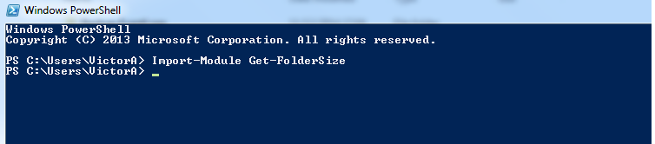

* To get help, type the command: Get-Help Get-FolderSize -Detailed

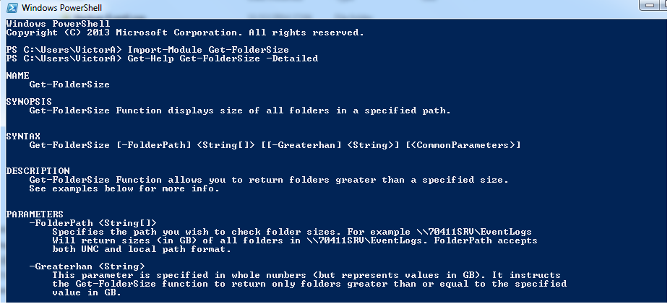

* To get full help information, type:

Get-Help Get-FolderSize -Full

* To return size for all folders in C:\EventLogs, run the command:

Get-FolderSize -FolderPath C:\EventLogs

The command returns the following output:

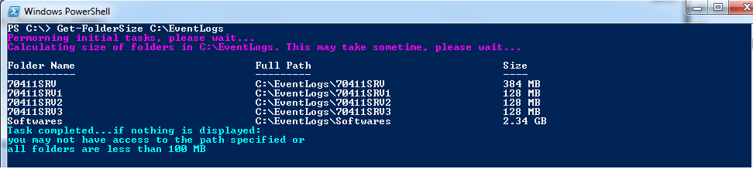

* To return size for folders in C:\EventLogs greater or equal to 100BM, run the command:

Get-FolderSize -FolderPath C:\EventLogs -FoldersOver 0.1

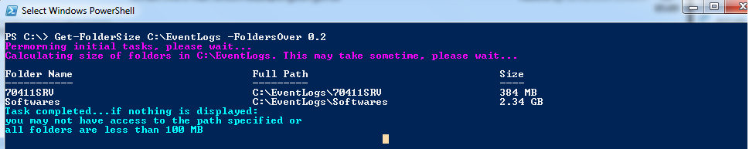

* To return size of all folders and subfolders, specify the Recurse parameter:

Get-FolderSize C:\EventLogs –Recurse

